**VIVEKANAND EDUCATION SOCIETY’S INSTITUTE OF TECHNOLOGY**

**An Autonomous Institute Affiliated to University of Mumbai**

**Department of Computer Engineering**



Project Report on

**Revolutionizing Hospital Management: Enhancing Patient Care through NFC Integration**

In partial fulfilment of the Fourth Year, Bachelor of Engineering (B.E.) Degree in Computer Engineering at the University of Mumbai Academic Year 2024-25

**Submitted by**

Sumeet Verlyani (D17 - B, Roll no - 62)

Muskan Talreja (D17 - B, Roll no - 55)

Neha Sewani (D17 - B, Roll no - 48)

Ravi Valecha (D17 - C, Roll no - 70)

**Project Mentor**

Mr. Prashant Kanade

(2024-25)

**VIVEKANAND EDUCATION SOCIETY’S INSTITUTE OF TECHNOLOGY**

**An Autonomous Institute Affiliated to University of Mumbai**

**Department of Computer Engineering**



**Certificate**

This is to certify that **Sumeet Verlyani (D17B - 62), Muskan Talreja (D17B - 55), Neha Sewani (D17B - 48), Ravi Valecha (D17C - 70)**of Fourth Year Computer Engineering studying under the University of Mumbai have satisfactorily completed the project on “**Revolutionizing Hospital Management: Enhancing Patient Care through NFC Integration**” as a part of their coursework of PROJECT-II for Semester-VIII under the guidance of their mentor **Mr. Prashant Kanade**in the year 2024-25.

This project report entitled **Revolutionizing Hospital Management: Enhancing Patient Care through NFC Integration** by **Sumeet Verlyani, Muskan Talreja, Neha Sewani, Ravi Valecha** is approved for the degree of **B.E. Computer Engineering.**

| Programme Outcomes | Grade |
| --- | --- |
| PO1, PO2, PO3, PO4, PO5, PO6, PO7, PO8, PO9, PO10, PO11, PO12,  PSO1, PSO2 |  |

Date:

Project Guide:

------------------------------------------

**Project Report Approval**

**For**

**B. E (Computer Engineering)**

This thesis/dissertation/project report entitled **Revolutionizing Hospital Management: Enhancing Patient Care through NFC Integration** by **Sumeet Verlyani, Muskan Talreja, Neha Sewani, Ravi Valecha** is approved for the degree of **B.E. Computer Engineering.**

Internal Examiner

---------------------------------------------

External Examiner

---------------------------------------------

Head of the Department

-----------------------------------------------

Principal

-----------------------------------------------

Date:

Place: Mumbai

**Declaration**

We declare that this written submission represents our ideas in our own words and where others' ideas or words have been included, we have adequately cited and referenced the original sources. We also declare that we have adhered to all principles of academic honesty and integrity and have not misrepresented or fabricated or falsified any idea/data/fact/source in our submission. We understand that any violation of the above will be cause for disciplinary action by the Institute and can also evoke penal action from the sources which have thus not been properly cited or from whom proper permission has not been taken when needed.

| -----------------------------------------  Sumeet Verlyani (D17B - 62) | -----------------------------------------  Muskan Talreja (D17B - 55) |
| --- | --- |
| -----------------------------------------  Neha Sewani (D17B - 48) | -----------------------------------------  Ravi Valecha (D17C - 70) |

Date:

**ACKNOWLEDGEMENT**

We are thankful to our college Vivekanand Education Society’s Institute of Technology for considering our project and extending help at all stages needed during our work of collecting information regarding the project.

It gives us immense pleasure to express our deep and sincere gratitude to Assistant Professor **Mr. Prashant Kanade** (Project Guide) for her kind help and valuable advice during the development of project synopsis and for her guidance and suggestions.

We are deeply indebted to Head of the Computer Department **Dr.(Mrs.) Nupur Giri** and our Principal **Dr. (Mrs.) J.M. Nair ,** for giving us this valuable opportunity to do this project.

We express our hearty thanks to them for their assistance without which it would have been difficult in finishing this project synopsis and project review successfully.

We convey our deep sense of gratitude to all teaching and non-teaching staff for their constant encouragement, support and selfless help throughout the project work. It is a great pleasure to acknowledge the help and suggestion, which we received from the Department of Computer Engineering.

We wish to express our profound thanks to all those who helped us in gathering information about the project. Our families too have provided moral support and encouragement several times.

**Computer Engineering Department**

**COURSE OUTCOMES FOR B.E PROJECT**

Learners will be to,

| **Course Outcome** | **Description of the Course Outcome** |
| --- | --- |
| CO 1 | Able to apply the relevant engineering concepts, knowledge and skills towards the project. |
| CO2 | Able to identify, formulate and interpret the various relevant research papers and to determine the problem. |
| CO 3 | Able to apply the engineering concepts towards designing solutions for the problem. |
| CO 4 | Able to interpret the data and datasets to be utilised. |
| CO 5 | Able to create, select and apply appropriate technologies, techniques, resources and tools for the project. |
| CO 6 | Able to apply ethical, professional policies and principles towards societal, environmental, safety and cultural benefit. |
| CO 7 | Able to function effectively as an individual, and as a member of a team, allocating roles with clear lines of responsibility and accountability. |
| CO 8 | Able to write effective reports, design documents and make effective presentations. |
| CO 9 | Able to apply engineering and management principles to the project as a team member. |
| CO 10 | Able to apply the project domain knowledge to sharpen one’s competency. |
| CO 11 | Able to develop a professional, presentational, balanced and structured approach towards project development. |
| CO 12 | Able to adopt skills, languages, environment and platforms for creating innovative solutions for the project. |

**Index**

**Abstract 8**

**Chapter 1: Introduction 9**

1.1 Introduction 9

1.2 Motivation 10

1.3 Problem Definition 10

1.4 Existing Systems 10

1.5 Lacuna of the existing systems 11

1.6 Relevance of the Project 11

**Chapter 2: Literature Survey 12**

A. Brief Overview of Literature Survey 12

B. Related Works 13

2.1 Research Papers Referred 13

2.2. Inference drawn 15

2.3 Comparison with the existing system 15

**Chapter 3: Requirement Gathering for the Proposed System 17**

3.1 Introduction to Requirement Gathering 17

3.2 Functional Requirements 17

3.3 Non-Functional Requirements 19

3.4 Hardware, Software, Technology and Tools utilised 20

**Chapter 4: Proposed Design 2****1**

4.1 Block diagram of the system 21

4.2 Modular design of the system 22

4.3 Detailed Design 23

4.4 Project Scheduling & Tracking using Timeline / Gantt Chart 24

**Chapter 5: Implementation of the Proposed System 2****5**

5.1. Methodology employed for development 25

5.2 Algorithms and flowcharts for the respective modules developed 26

5.3 Datasets source and utilisation 26

**Chapter 6:** **Testing of the Proposed System** **2****7**

6.1. Introduction to testing 27

6.2. Types of test Considered 28

6.3. Various test scenarios considered 28

6.4. Inference drawn from the test cases 28

**Chapter 7: Results and Discussion** **29**

7.1. Screenshots of the User Interface (UI) for the respective module 30

7.2. Performance Evaluation measures 32

7.3. Input Parameters / Features Considered 33

7.4. Graphical and statistical output 34

7.5 Comparison of results with existing systems 35

7.6. Inference drawn 36

**Chapter 8: Conclusion** **37**

8.1 Limitations 37

8.2 Conclusion 37

8.3 Future Scope 37

**References** **39**

**Appendix** **40**

**1. Paper I & II Details** **40**

a. Paper published 40

b. Plagiarism report 40

c. Project review sheet 41

# Abstract

Efficient and centralized hospital management systems play a pivotal role in transforming contemporary healthcare delivery by improving patient care, administrative accuracy, and interhospital communication. This paper presents the development and deployment of an advanced patient healthcare platform integrated with Near Field Communication (NFC) technology, enabling instant and secure access to a patient's complete medical history via a single NFC card. The system eliminates the need for patients to carry multiple documents, facilitating seamless treatment across interconnected healthcare facilities. It offers actionable insights for medical practitioners, system architects, and policy developers focused on building intelligent, patient-centric healthcare ecosystems.

# 

# Chapter 1: Introduction

## 1.1 Introduction

In the modern era of digitization, the healthcare industry is undergoing a significant transformation through the integration of advanced technologies to streamline operations, improve patient care, and enhance clinical outcomes. Among the most critical components in this transformation is the implementation of efficient hospital and patient management systems. These systems aim to reduce the burden of manual administrative work, eliminate redundancies, and ensure the accurate and timely delivery of healthcare services.

The Patient Management System proposed in this project leverages Near Field Communication (NFC) technology to provide a secure, efficient, and real-time mechanism for accessing and managing patient records. NFC, a short-range wireless communication technology, enables data exchange between devices with a simple tap or scan, offering convenience, speed, and accuracy—features that are essential in healthcare environments where time-sensitive decisions are routine.

Traditional hospital record-keeping practices, often reliant on paper-based documentation and fragmented digital systems, can be inefficient and error-prone. These limitations can lead to delayed diagnosis, repeated tests, misplaced documents, and a lack of real-time access to critical patient data. With the integration of an NFC-based system, healthcare providers can instantly retrieve a patient’s medical history, prescriptions, and previous treatments with a simple scan, significantly reducing wait times and enhancing the precision of care delivery.

This system not only benefits healthcare providers but also empowers patients by giving them more control and transparency over their health data. Through an intuitive interface, patients can view appointments, prescriptions, and medical history, and communicate securely with doctors and pharmacists. The centralized database and role-based access further ensure that only authorized users can access or modify sensitive medical data, thereby maintaining compliance with data privacy standards and regulations.

The broader vision of this project extends beyond hospital walls. It includes seamless interoperability, real-time health monitoring, telemedicine integration, and analytics for informed decision-making. As healthcare demands continue to grow, especially in densely populated countries like India, the need for scalable, secure, and smart systems becomes imperative.

In conclusion, the NFC-enabled Patient Management System proposed in this project serves as a vital step toward the digitization of healthcare. It promises improved operational efficiency, enhanced patient engagement, reduced errors, and more effective resource utilization—ultimately contributing to a smarter, safer, and more responsive healthcare ecosystem.

## 1.2 Motivation

The rapid advancement of technology in all sectors has created an expectation for faster, smarter, and more efficient services—healthcare being no exception. However, many healthcare institutions still rely on outdated systems that cause delays, inefficiencies, and errors in patient care. The motivation behind this project stems from the pressing need to improve hospital workflow, data management, and patient experience through automation and real-time access to information. By integrating NFC technology, this system aims to revolutionize patient interaction with hospitals, making processes such as check-ins, record retrieval, and prescription access faster, easier, and more secure. The goal is to create a streamlined healthcare environment that benefits patients, doctors, and administrative staff alike.

## 1.3 Problem Definition

Despite significant technological advancements, many hospitals continue to struggle with fragmented patient data systems, manual appointment scheduling, and slow access to medical records, which can compromise timely care. These inefficiencies not only burden healthcare workers but also cause frustration for patients, especially during emergencies. The core problem lies in the lack of a unified, secure, and real-time management system that can handle patient data, facilitate communication, and streamline workflows. This project addresses the need for an intelligent, NFC-based patient management system that centralizes hospital data operations and enhances accessibility for all stakeholders in the healthcare ecosystem.

## 1.4 Existing Systems

Existing hospital management systems often rely on conventional methods, including paper-based records and basic database applications with limited user interactivity and accessibility. While some modern systems offer digital records or appointment booking features, they typically lack real-time integration, role-specific access, and the seamless interconnectivity required for efficient healthcare delivery. Many of these systems are not optimized for remote access, scalability, or rapid data retrieval, and rarely integrate technologies like NFC for enhanced convenience. Consequently, patient care remains delayed, administrative overheads are high, and errors in treatment or record-keeping are common in many such systems.

## 1.5 Lacuna of the existing systems

The key gaps in existing systems include the lack of automation, absence of intelligent decision support tools, minimal use of emerging technologies like IoT and NFC, and limited interoperability with other medical platforms. Additionally, these systems often do not support role-based access, leading to potential security issues and inefficiencies in task delegation. Patient engagement is also typically low, with very few systems allowing patients direct access to their medical records or communication with their doctors. These shortcomings highlight the urgent need for a smarter, more connected, and technologically advanced patient management system tailored for today’s healthcare challenges.

## 1.6 Relevance of the Project

This project is highly relevant in the context of today's fast-paced, digital-first world, where efficient healthcare delivery is critical. With increasing patient volumes and the growing complexity of medical treatments, hospitals need systems that ensure data accuracy, reduce administrative workload, and provide timely access to critical patient information. By integrating NFC technology and embedding role-based access, the proposed system not only addresses the inefficiencies in traditional models but also introduces a user-friendly, scalable, and secure solution. It is particularly pertinent in post-pandemic times, where contactless, remote, and data-driven healthcare solutions are becoming the new norm.

# 

# 

# 

# Chapter 2: Literature Survey

## A. Brief Overview of Literature Survey

The evolution of healthcare technologies has seen significant growth over the last two decades, with increasing emphasis on electronic health records (EHRs), decision support systems, and integrated platforms for hospital management. The literature indicates that many hospitals and clinics are adopting patient management systems to improve efficiency, reduce paperwork, and enhance the quality of care. A wide range of studies have explored the benefits of centralized health information systems, focusing on areas such as appointment scheduling, prescription management, and real-time access to patient history. These systems have shown positive impacts on reducing patient wait times, improving diagnosis accuracy, and enabling better tracking of patient outcomes. Researchers have also highlighted the need for role-based access and enhanced data security to prevent unauthorized access to sensitive health data, especially as systems scale up in complexity and usage.

In recent years, there has been a noticeable shift towards integrating advanced technologies like IoT, AI, and NFC into hospital environments. Several studies have emphasized the potential of Near Field Communication (NFC) technology in healthcare for its ease of use, low cost, and ability to provide quick access to critical patient data via secure scanning mechanisms. NFC-enabled systems are being increasingly recognized for their potential in streamlining patient check-ins, improving medication adherence through digital prescriptions, and enhancing emergency response through instant retrieval of medical records. The literature supports the argument that when integrated thoughtfully, technologies like NFC can bridge the gap between traditional healthcare workflows and the growing demand for digital, patient-centric solutions. These insights have laid the groundwork for this project, which aims to build upon existing research and contribute to the development of a smarter, more responsive hospital management system.

## 

## 

## 

## 

## B. Related Works

## 2.1 Research Papers Referred

1. **NFC based Smart Healthcare Services System** *Abstract:* Near Field Communication (NFC) applications have the potential to revolutionize the organization of medical services globally by creating new methods for completing tasks and connecting with individuals and information. By simplifying the exchange of digital information between patients, providers, and health organizations, NFC can help transform the current healthcare system, reduce medical expenses, and enhance care. This paper proposes a fundamental design for smart healthcare services utilizing NFC to facilitate the provisioning of medical services to patients anywhere, anytime, using smartphones connected through wireless communication technologies. ​[ResearchGate](https://www.researchgate.net/publication/337731145_NFC_based_Smart_Healthcare_Services_System?utm_source=chatgpt.com) *Inference Drawn:* The study demonstrates that integrating NFC technology into healthcare services can significantly enhance the efficiency and accessibility of medical care. By enabling seamless communication between patients and healthcare providers, NFC can reduce operational costs and improve patient outcomes.​
2. **UHF RFID and NFC Point-of-Care -- Architecture, Security, and Implementation** *Abstract:* Points-of-care (PoCs) augment healthcare systems by performing care whenever needed and are becoming increasingly crucial for the well-being of the worldwide population. Personalized medicine, chronic illness management, and cost reduction can be achieved thanks to the widespread adoption of PoCs. Significant incentives for PoCs deployment are nowadays given by wearable devices and, in particular, by RFID (RadioFrequency IDentification) and NFC (Near Field Communications), which are rising among the technological cornerstones of the healthcare internet of things (H-IoT). To fully exploit recent technological advancements, this paper proposes a system architecture for RFID- and NFC-based PoCs. The architecture comprises in a unitary framework both interfaces to benefit from their complementary features, and gathered data are shared with medical experts through secure and user-friendly interfaces that implement the Fast Health Interoperability Resource (FHIR) emerging healthcare standard. The selection of the optimal UHF and NFC components is discussed concerning the employable sensing techniques. The secure transmission of sensitive medical data is addressed by developing a user-friendly "PoC App" that is the first web app exploiting attribute-based encryption (ABE). An application example of the system for monitoring the pH and cortisol levels in sweat is implemented and preliminarily tested by a healthy volunteer. ​[arXiv](https://arxiv.org/abs/2304.08015?utm_source=chatgpt.com) *Inference Drawn:* The research highlights the potential of integrating UHF RFID and NFC technologies in point-of-care systems to enhance personalized medicine and chronic illness management. The proposed architecture ensures secure and efficient transmission of sensitive medical data, demonstrating the feasibility of real-time health monitoring through wearable devices.​[arXiv](https://arxiv.org/abs/2304.08015?utm_source=chatgpt.com)
3. **Host Card Emulation** *Abstract:* Host card emulation (HCE) is the software architecture that provides exact virtual representation of various electronic identity (access, transit, and banking) cards using only software. Prior to the HCE architecture, near field communication (NFC) transactions were mainly carried out using hardware-based secure elements. HCE enables mobile applications running on supported operating systems to offer payment card and access card solutions independently of third parties while utilizing cryptographic processes traditionally used by hardware-based secure elements without the need for a physical secure element. This technology enables merchants to offer payment card solutions more easily through mobile closed-loop contactless payment solutions, offers real-time distribution of payment cards, and allows for an easy deployment scenario that does not require changes to the software inside payment terminals. ​[Wikipedia](https://en.wikipedia.org/wiki/Host_card_emulation?utm_source=chatgpt.com) *Inference Drawn:* The implementation of HCE allows for more flexible and cost-effective deployment of NFC-based payment and access solutions. By eliminating the need for physical secure elements, HCE simplifies the process for merchants and service providers to offer contactless services, potentially accelerating the adoption of NFC technology in various sectors.​
4. **Near-Field Communication** *Abstract:* Near-field communication (NFC) is a set of communication protocols that enables communication between two electronic devices over a distance of 4 cm or less. NFC offers a low-speed connection through a simple setup that can be used for bootstrapping more capable wireless connections. Like other proximity card technologies, NFC is based on inductive coupling between two electromagnetic coils present on an NFC-enabled device such as a smartphone. NFC communicating in one or both directions uses a frequency of 13.56 MHz in the globally available unlicensed radio frequency ISM band, compliant with the ISO/IEC 18000-3 air interface standard at data rates ranging from 106 to 848 kbit/s. ​[Wikipedia](https://en.wikipedia.org/wiki/Near-field_communication?utm_source=chatgpt.com) *Inference Drawn:* NFC technology facilitates secure and efficient short-range communication between devices, making it suitable for applications like contactless payments, access control, and data exchange. Its ease of use and integration into mobile devices have contributed to its widespread adoption in various industries.
5. **Intelligent Hospital Management System (IHMS)**

*Abstract:* This paper presents the design and implementation of an Intelligent Hospital Management System (IHMS) aimed at improving the information flow within a hospital. The system automates various hospital functions, including patient registration, doctor appointment scheduling, billing, and reporting. A key aspect of the system is the inclusion of a smart front desk interface for assisting patients. Doctors benefit from a software-assisted diagnosis feature using intelligent decision mechanisms, enabling quicker and more informed medical decisions.

*Inference Drawn:* The IHMS system emphasizes automation in hospital administration and intelligent assistance for medical practitioners. However, it lacks cross-hospital data access and NFC integration, which limits real-time portability and access to patient history—gaps that the proposed NFC-based system aims to bridge.

1. **NFC tag-based mHealth Patient Healthcare Tracking System**

*Abstract:* This paper introduces an NFC-based mobile health (mHealth) system that uses NFC tags attached to patients to track and manage their health records. The system facilitates the use of mobile devices to access and update patient data on the go. It aims to enhance patient monitoring and ensure healthcare information is readily available to doctors and caregivers, reducing paperwork and increasing the efficiency of care delivery.

*Inference Drawn:* This paper confrms the utility of NFC technology in healthcare settings by simplifying access to health records and enabling mobile-based tracking. It supports the feasibility of integrating NFC in real-time hospital environments and validates the design direction of our proposed system.

## 2.2 Inference Drawn

The literature surveyed highlights the evolving landscape of healthcare technologies, with increasing emphasis on digitization, mobility, and automation. Across the reviewed research papers, one consistent theme is the need for seamless access to patient data, real-time monitoring, and secure communication between stakeholders. Technologies like RFID, IoT, and especially NFC are being explored as practical tools for enabling portable, contactless access to critical health information.

A key inference drawn is that while many existing solutions offer valuable features—such as mobile health tracking, smart hospital automation, and cloud-based health records—most systems are limited either by scope (e.g., restricted to a single hospital) or lack integration between modules. Additionally, data retrieval delays, minimal patient involvement, and lack of real-time emergency access continue to affect operational efficiency in traditional systems.

The reviewed studies validate the relevance and timeliness of integrating NFC technology into a unified hospital management platform. The insights confirm that the proposed system not only aligns with global healthcare tech trends but also addresses practical challenges in day-to-day clinical environments by centralizing records and offering secure, role-based access through NFC cards.

## 2.3 Comparison with the existing system

| **Feature** | **Existing Systems** | **Proposed NFC-Based System** |
| --- | --- | --- |
| **Data Access** | Fragmented, often hospital-specific | Centralized, accessible across any NFC-enabled point |
| **Technology Used** | Basic web portals, barcode scanners, manual updates | NFC cards, Laravel framework, real-time web portal |
| **Patient Identification** | Manual verification or RFID-based | Unique NFC ID instantly mapped to patient profile |
| **Emergency Access** | Time-consuming; requires form filling or manual searches | Instant access to medical history via NFC card |
| **Role-Based Functionality** | Often minimal or same interface for all users | Dedicated dashboards for doctor, patient, pharmacist, and admin |
| **Mobility** | Limited to internal hospital systems | Web-based access + NFC portability via mobile-enabled readers |
| **Prescription Management** | Mostly manual or tied to desktop systems | Digitally generated prescriptions, accessible by both doctors & pharmacists |
| **User Engagement** | Low; patients are mostly passive users | Patients have direct access to data, appointments, and prescriptions |
| **Security & Privacy** | Basic password protection | Role-based access control + encrypted data handling |
| **Integration Capabilities** | Poor interoperability with external systems | Designed for scalability and integration with other hospital tools |

**Table 2.3.1 Comparison of Existing Systems**

# 

# Chapter 3: Requirement Gathering for the Proposed System

## 3.1 Introduction to Requirement Gathering

Requirement gathering is a crucial phase in the software development life cycle as it forms the foundation upon which the entire system is built. For the successful implementation of the NFC-based Hospital Patient Management System, it is essential to identify, analyze, and document both functional and non-functional requirements. These requirements were gathered through stakeholder interviews, observation of existing hospital processes, and analysis of similar healthcare management systems. This phase ensures that the final product aligns with user needs and expectations while addressing real-world challenges encountered by patients, doctors, administrators, and pharmacists. The table below summarizes the primary sources and techniques used for gathering requirements for this system.

| SOURCE | REQUIREMENT GATHERING TECHNIQUE | PURPOSE |
| --- | --- | --- |
| Hospital Staff (Doctors, Admins, Pharmacists) | Interviews and questionnaires | To understand role-specific needs and system expectations |
| Existing Hospital Management Software | Comparative analysis | To identify limitations and potential improvements |
| Patients | Surveys and feedback sessions | To capture usability expectations and common issues |
| Technical Experts | Brainstorming and feasibility discussions | To define the technological scope and infrastructure |
| Regulatory Guidelines (HIPAA, etc.) | Documentation review | To ensure data security and compliance |

**Table 3.1.1 Requirements of the system**

## 3.2 Functional Requirements

1. **User Registration and Authentication:**

The system must support secure registration and login functionalities for different user roles including patients, doctors, administrators, and pharmacists. This ensures personalized access and maintains role-specific privileges.

1. **Patient Profile Management:**

Patients can create, view, and update their personal and medical information including allergies, past diagnoses, treatments, and insurance details.

1. **Doctor Profile Management:**

Doctors can maintain their professional profiles, view patient histories, and manage their schedule for appointments and consultations.

1. **Appointment Scheduling and Management:**

The system must allow patients to book, reschedule, or cancel appointments. Doctors should be able to manage their availability and view upcoming appointments.

1. **Electronic Health Records (EHR) Maintenance:**

The system should provide capabilities to store and retrieve complete patient history, including test reports, diagnoses, treatment plans, and past hospital visits.

1. **Prescription Generation and Management:**

Doctors must be able to create and issue electronic prescriptions, which can be accessed by pharmacists to ensure proper dispensing of medication.

1. **NFC Card Integration for Record Access:**

Patients should be able to tap their NFC card to securely access their profile and records without manual input, enhancing efficiency and reducing wait time.

1. **Alerts and Notifications:**

The system must send alerts for upcoming appointments, prescription reminders, and health updates via SMS, email, or in-app notifications.

1. **Internal Communication System:**

Secure messaging should be available between patients and doctors, and between staff members, to coordinate care and share updates.

1. **Reporting and Analytics:**

The system should provide reports on appointment trends, patient visits, drug usage, and overall system performance to help administrators make data-driven decisions.

1. **Role-Based Access Control (RBAC):**

Ensure that access to system features and data is restricted based on user roles to maintain confidentiality, data integrity, and system security.

## 3.3 Non-Functional Requirements

1. **Performance and Scalability:**

The system should perform efficiently even under high loads, such as during peak hours. It must also scale to accommodate an increasing number of users, records, and transactions without degradation in performance.

1. **Security:**

As the system deals with sensitive personal and medical data, robust security measures like encryption, secure authentication, and role-based access control must be implemented to prevent data breaches and unauthorized access.

1. **Usability:**

The system should have a user-friendly interface for all user roles (patients, doctors, admins, pharmacists), enabling intuitive navigation and interaction, even for users with minimal technical background.

1. **Availability and Reliability:**

The system must maintain high availability (e.g., 99.9% uptime) and function reliably at all times to support critical healthcare operations, including emergency patient access and real-time updates.

1. **Maintainability:**

The codebase and system design should follow modular, well-documented practices so that the system can be easily maintained, debugged, and enhanced in the future.

1. **Interoperability:**

The system should be compatible with other hospital subsystems such as billing, laboratory, and pharmacy systems to support data sharing and avoid redundancy.

1. **Data Backup and Recovery:**

Regular backups and an efficient data recovery mechanism must be in place to protect data against accidental loss, corruption, or system failures.

1. **Compliance with Healthcare Standards:**

The system should comply with relevant healthcare regulations such as HIPAA or local data protection laws to ensure legal and ethical data handling.

1. **Localization and Language Support:**

For wider accessibility, especially in multilingual regions, the system should support multiple languages and regional settings.

1. **Responsiveness:**

The system interface should be responsive across various devices, including desktops, tablets, and mobile phones, ensuring accessibility on-the-go.

## 3.4 Hardware, Software, Technology and Tools utilised

**Hardware Requirements:**

1. **NFC Reader / NFC-Enabled Mobile Device:**

The system is designed to utilize NFC (Near Field Communication) technology for accessing patient records. While dedicated NFC card readers can be used in a hospital setup, for the purpose of this project, NFC-enabled smartphones were used to scan and read patient NFC cards. This approach adds portability and reduces initial hardware costs.

1. **Computer System / Server:**

A general-purpose computer or server is required to host the backend of the application, including the Laravel framework and MySQL database. It serves as the central control unit for managing all user interactions and data storage.

**Software Requirements:**

1. **Laravel Framework (v7):**

Laravel, a PHP-based web application framework, was used to develop the server-side logic of the system. Laravel v7 offers robust features such as routing, middleware, MVC architecture, and built-in security which streamline backend development and maintenance.

1. **MySQL Database:**

MySQL was used for data storage and management. It is a reliable and scalable relational database management system, ideal for storing structured data such as patient records, appointments, prescriptions, and system logs.

1. **Web Server:**

A web server is required to serve the Laravel application and handle HTTP requests. Apache or Nginx can be configured based on deployment preferences.

1. **Operating System:**

The system is platform-independent but was primarily developed and tested on Windows/Linux environments for both local development and deployment purposes.

**Tools and Technologies Used:**

1. **Frontend:** HTML, CSS, JavaScript (for UI and interaction)
2. **Backend:** PHP (Laravel v7)
3. **Database:** MySQL
4. **NFC Integration:** NFC-enabled Android smartphones using standard NFC libraries
5. **Version Control:** Git (for code collaboration and version tracking)

# Chapter 4: Proposed Design

## 4.1 Block diagram of the system

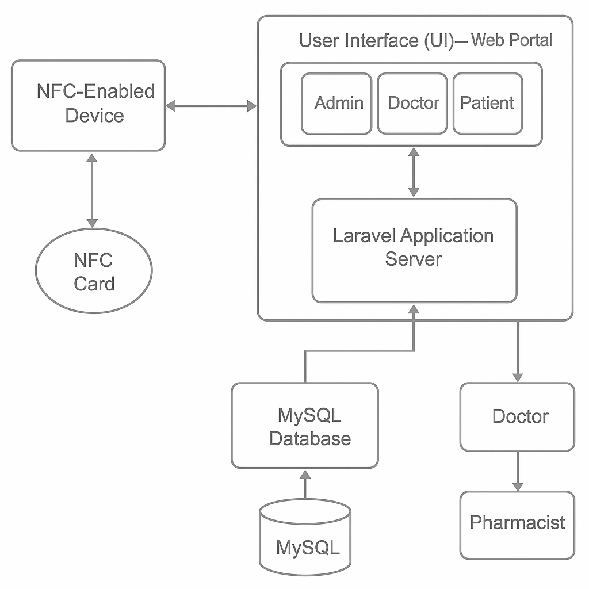

**Figure 4.1.1 Block diagram of the System**

## 4.2 Modular design of the system

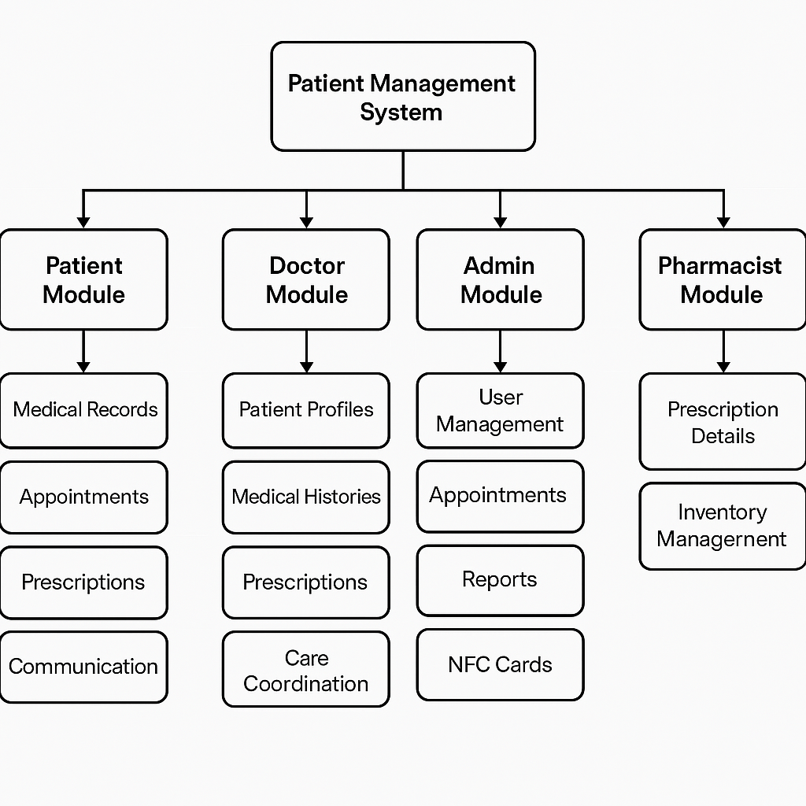

**Figure 4.2.1 Modular diagram of the System**

## 4.3 Detailed Design

# 

**Figure 4.3.1 Detailed design of the System**

## 4.4 Project Scheduling & Tracking using Timeline / Gantt Chart

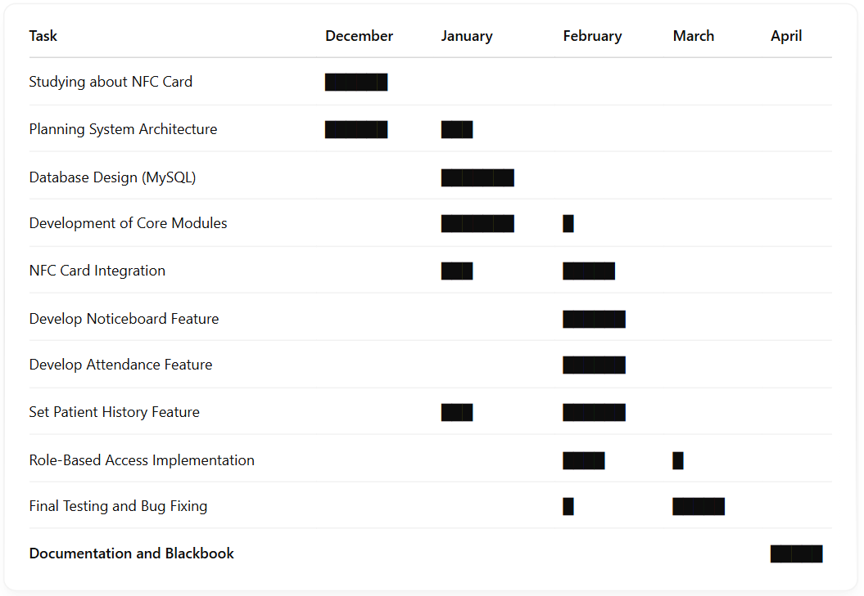

**Figure 4.4.1 Gantt Chart of development of project**

# 

# 

# Chapter 5: Implementation of the Proposed System

## 5.1. Methodology employed for development

The development of the NFC-based Hospital Patient Management System was carried out using a **modular development approach** inspired by Agile methodology. The system was divided into smaller functional modules such as user management, appointment scheduling, patient history, and NFC integration, allowing parallel development and testing.

The process began with requirement analysis and system design, followed by database setup using MySQL and backend development using Laravel v7. Each module was developed individually and tested before being integrated into the main system. The NFC integration was implemented using NFC-enabled smartphones, enabling real-time patient record access through unique card IDs.

This step-wise approach ensured flexibility, easy debugging, and smooth integration of components, leading to the creation of a secure, efficient, and scalable patient management platform.

## 5.2 Algorithms and flowcharts for the respective modules developed

#### **1. NFC Card Scanning Algorithm:**

1. Start
2. Scan NFC card using NFC-enabled device
3. Extract unique patient ID from NFC tag
4. Send request to Laravel backend with the extracted ID
5. Fetch patient details from MySQL database
6. If data is found:  
      → Display patient information on the doctor/admin interface  
    Else:  
      → Show error message ("Patient not found")
7. End

#### **2. Flowchart**

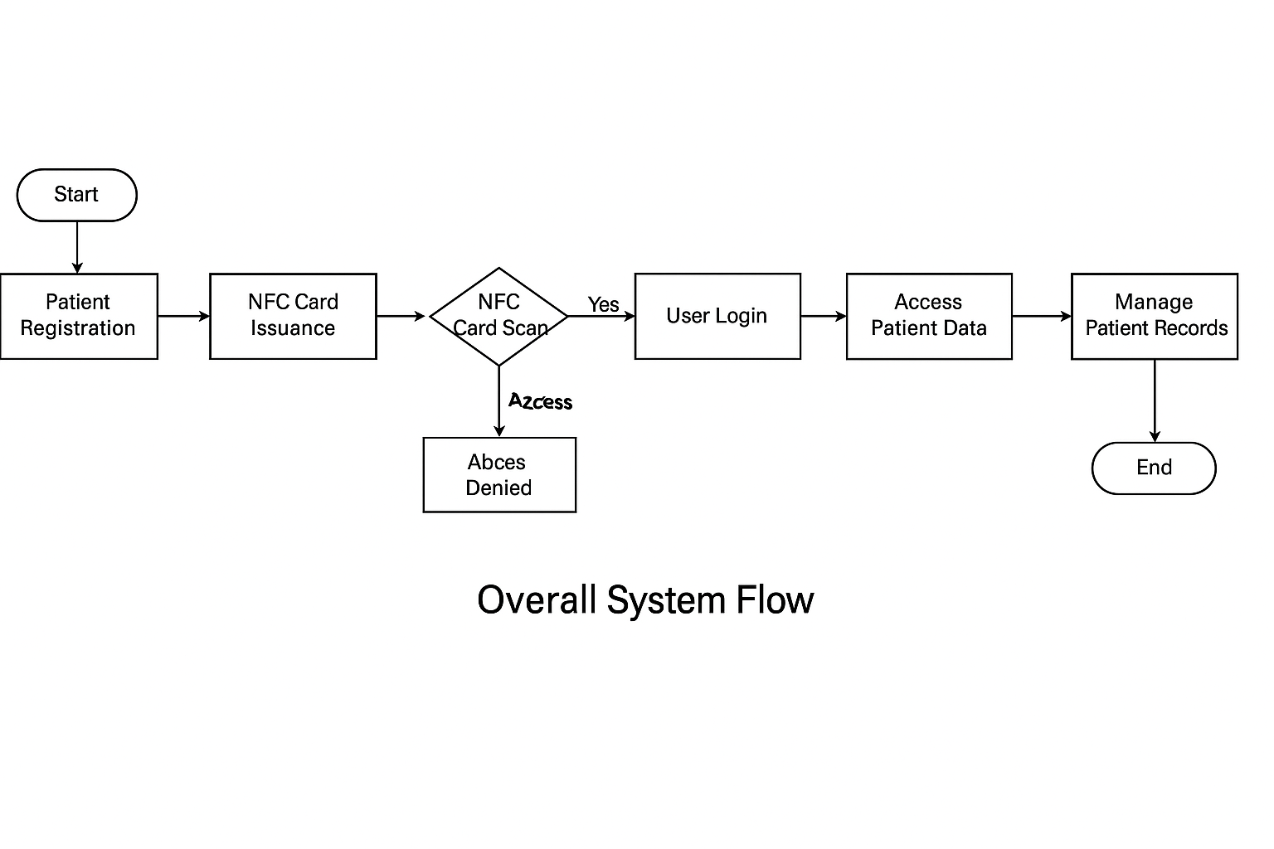

**Figure 5.2.1 Overall System Flowchart**

## 5.3 Datasets source and utilisation

Since the proposed NFC-based Hospital Patient Management System is a custom-built project, the dataset was manually created to simulate real-world hospital operations and patient interactions. The system does not rely on publicly available datasets due to the sensitive and private nature of healthcare records. Instead, mock data representing realistic patient profiles, appointment schedules, prescriptions, and user roles was generated for development, testing, and validation purposes.

#### **Dataset Sources:**

* **Synthetic Patient Records:** Custom data was created to include patient names, age, gender, contact details, medical history, allergies, and past treatments.
* **Doctor Profiles:** Sample data was added to represent doctors across different specializations with available slots for appointments.
* **Prescription Logs:** Test prescriptions were generated with medication names, dosage, and issue dates for integration with pharmacist modules.
* **Appointment Data:** Sample appointment requests and schedules were used to test date-time conflict handling and notification systems.
* **NFC Identifier Mapping:** Each mock patient was assigned a unique NFC tag value (simulated as alphanumeric strings), linked to their profile in the database.

#### **Utilisation of Dataset:**

* **Development & Testing:** All modules were tested using the generated dataset to verify data retrieval, NFC card linking, appointment workflows, and role-based access.
* **Performance Evaluation:** The data was used to simulate load on the system, ensuring response time and performance under multiple concurrent user actions.
* **Security Validation:** The dataset helped validate access control logic, confirming that sensitive data is only accessible to authorized users based on roles.
* **Demonstration & Presentation:** Mock data was used to showcase system functionality during internal reviews, viva, and practical demonstrations.  
  ng in Adults" and "Autism Screening in Toddlers." These datasets were merged to form a comprehensive dataset encompassing individuals across different age groups for autism spectrum disorder (ASD) screening analysis.

# Chapter 6: Testing of the Proposed System

## 6.1. Introduction to testing

Testing is a critical phase in the software development life cycle, aimed at verifying the system's functionality, performance, reliability, and compliance with the specified requirements. For the NFC-based Hospital Patient Management System, rigorous testing was conducted to ensure the robustness and accuracy of the application in a healthcare setting. The objective was to identify bugs, validate expected behaviors, and confirm that all modules—especially those involving NFC card reading and role-based access—performed seamlessly under real-world conditions. Testing also evaluated the responsiveness of the system, the security of data handling, and the user experience across different roles.

## 6.2 Types of test Considered

To achieve comprehensive system validation, the following types of testing were conducted:

* **Unit Testing:** Individual components such as login modules, patient profile creation, and appointment scheduling were tested in isolation to verify logical correctness.
* **Integration Testing:** Ensured smooth data flow between modules—for example, testing how NFC scanning interacts with the backend to fetch records, or how prescription data is passed to the pharmacist module.
* **System Testing:** The entire application was tested end-to-end using synthetic data to validate that all functionalities worked as expected in a fully integrated environment.
* **Usability Testing:** Focused on user interface clarity, ease of navigation, and response time across different devices and user roles.
* **Security Testing:** Verified data protection through role-based access control, preventing unauthorized users from accessing or altering patient data.

## 6.3 Various test scenarios considered

| **Test Scenario** | **Expected Output** | **Result** |
| --- | --- | --- |
| Scanning valid NFC card | Patient profile displayed instantly | Pass |
| Scanning invalid NFC card | Error message displayed | Pass |
| Booking an appointment in an available slot | Appointment confirmed and saved | Pass |
| Booking overlapping appointment slot | Conflict warning displayed | Pass |
| Login with correct credentials (Doctor) | Doctor dashboard loads with patient list | Pass |
| Login with wrong credentials | Login failure message shown | Pass |
| Patient updates profile | Changes saved and reflected in the database | Pass |
| Pharmacist retrieves prescription | Accurate medication list retrieved | Pass |
| Unauthorized user accessing admin panel | Access denied | Pass |
| System downtime simulation | Automatic error handling message shown | Pass |

## 6.4 Inference drawn from the test cases

Based on the testing process, it was concluded that the system meets all functional and non-functional requirements defined during the requirement analysis phase. The system reliably performs its core tasks—especially NFC-based record access, appointment handling, and secure role-based operations—without data loss or system crashes. Edge cases and exception handling (e.g., invalid card scans, conflicting bookings) were also successfully managed. The smooth operation of modules across different devices and user roles affirms the scalability and practical feasibility of the system for real-world hospital deployment.

# 

# Chapter 7: Results and Discussion

## 7.1. Screenshots of the User Interface (UI) for the respective module

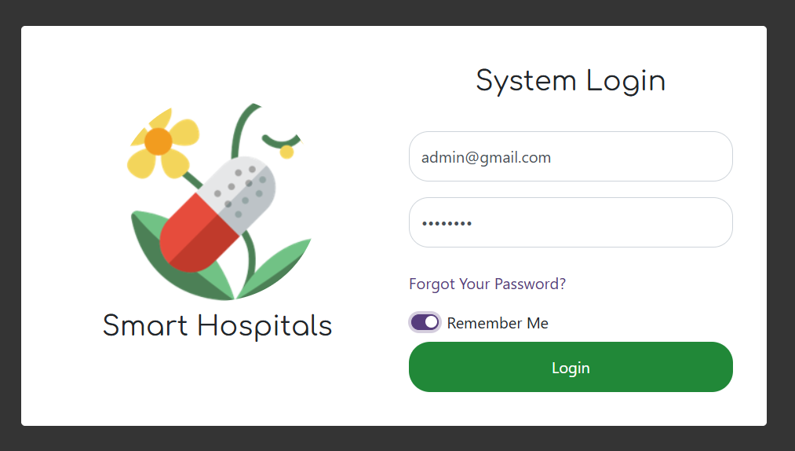

**Figure 7.11.1 Login Page**

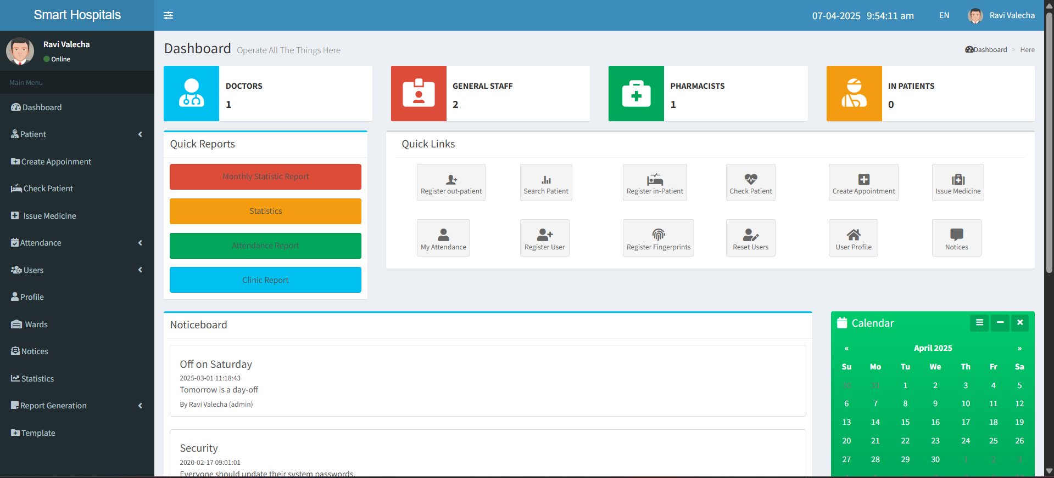

**Figure 7.11.2 Dashboard**

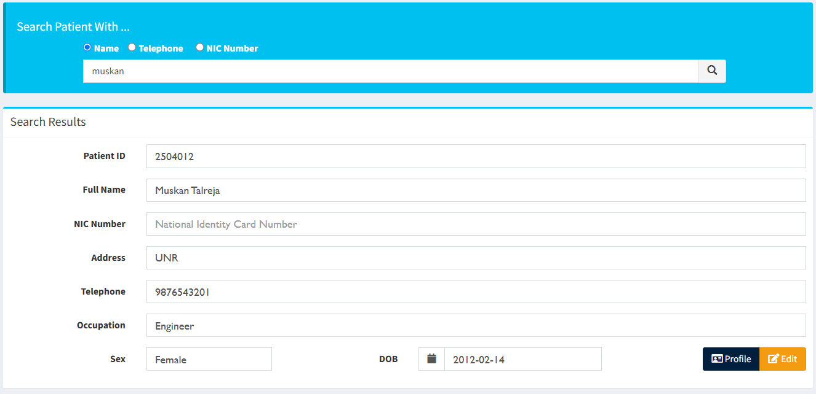

**Figure 7.11.3 Create, View, Search Patient**

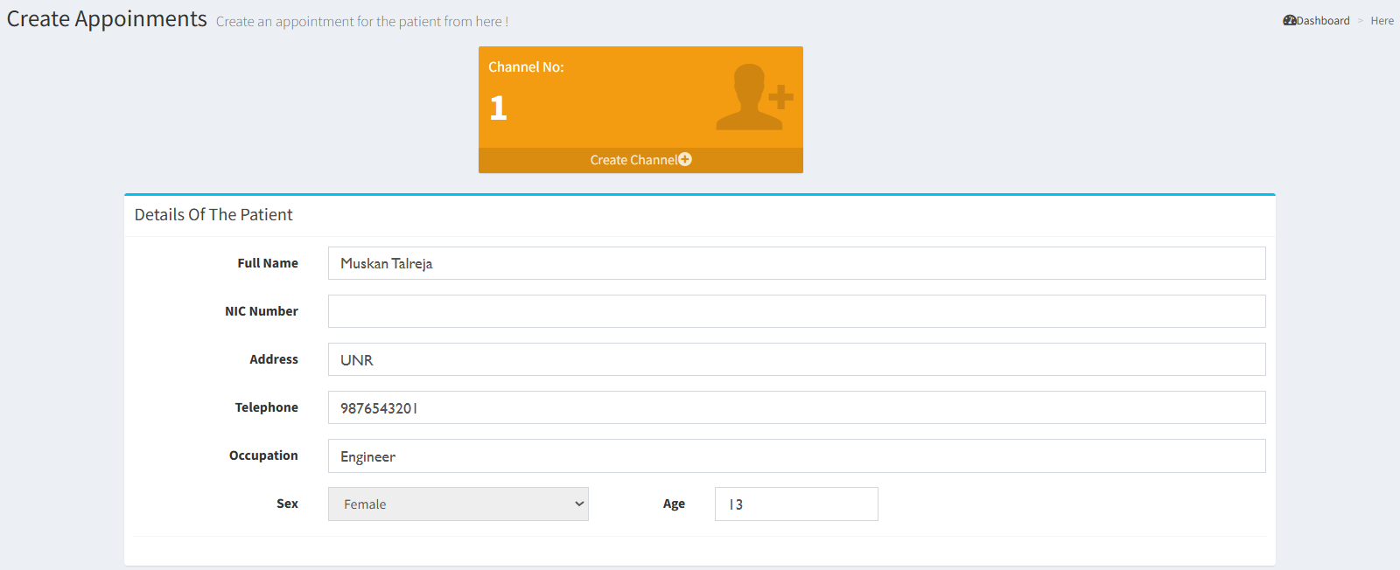

**Figure 7.11.4 Create Appointment**

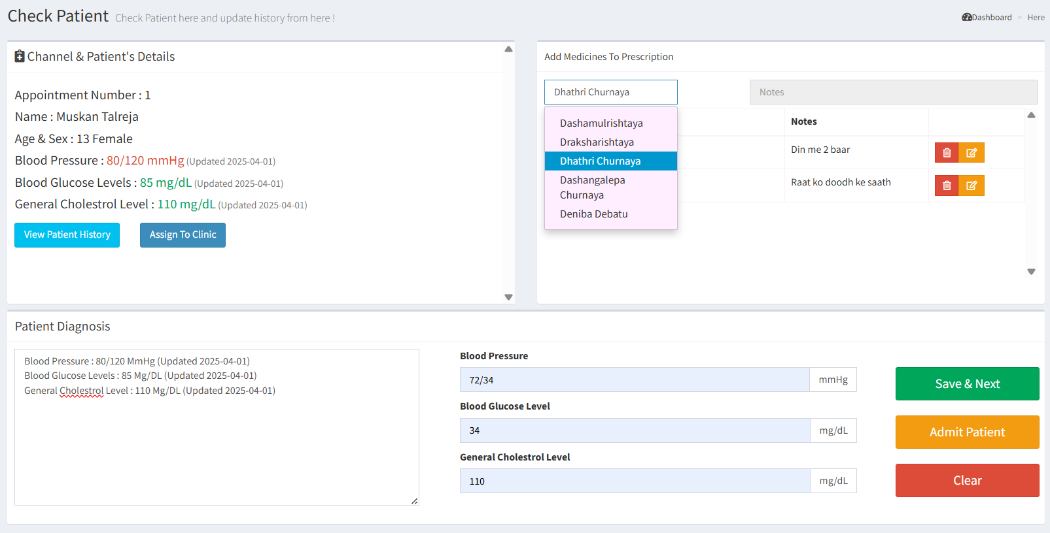**Figure 7.11.5 Check Patient**

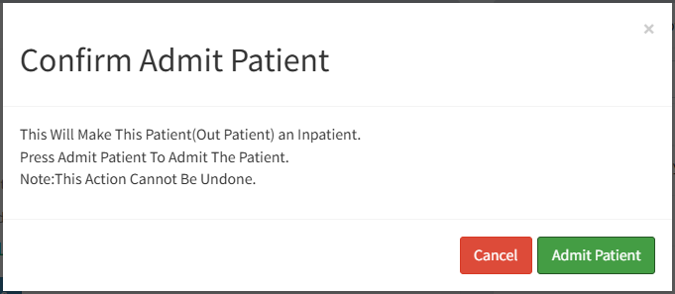

**Figure 7.11.6 Admit Patient**

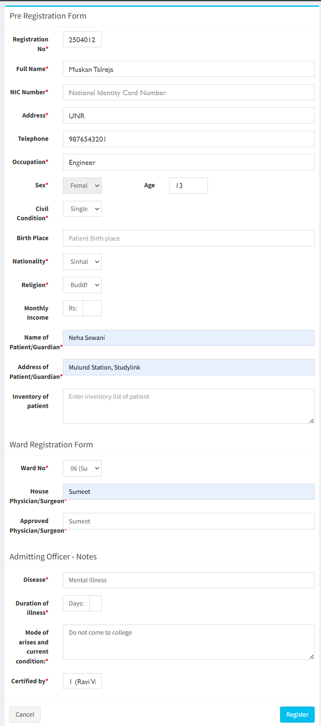

**Figure 7.11.7 Register InPatient**

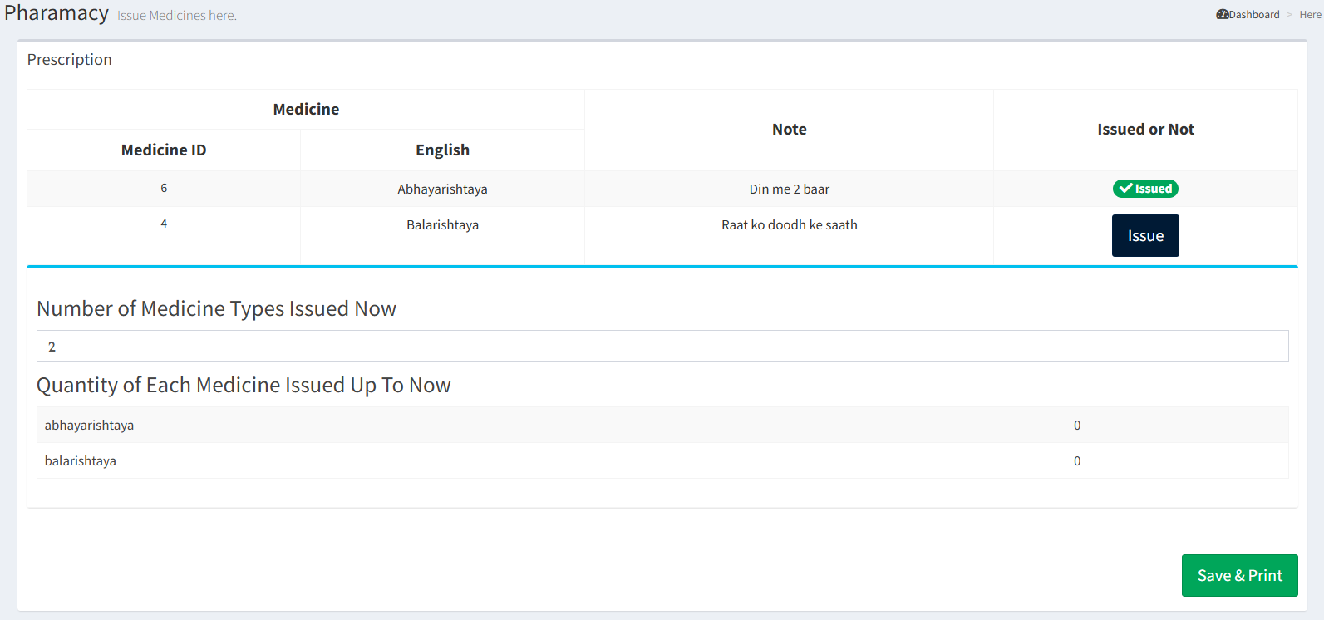

**Figure 7.11.8 Issue Medicines - Pharmacy**

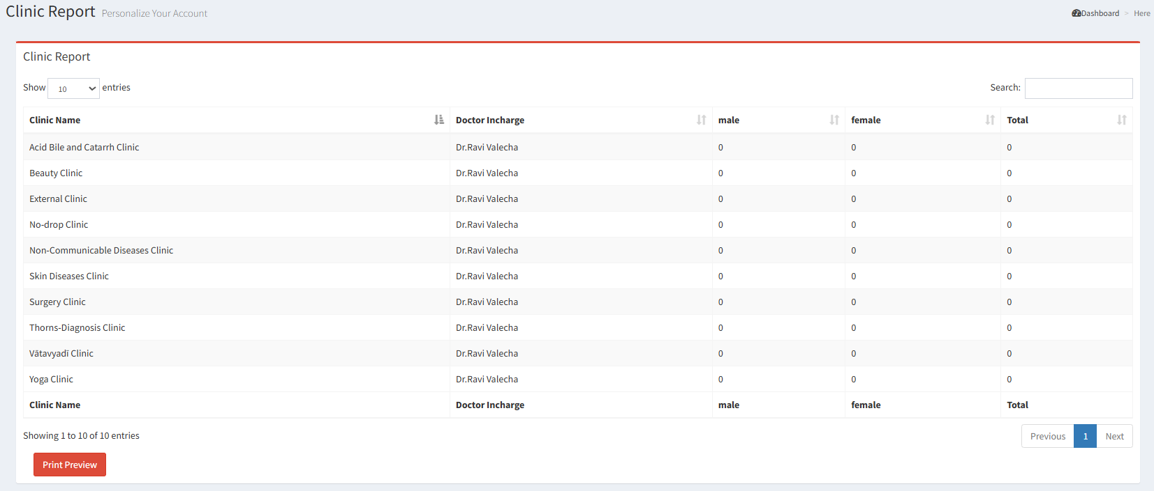

**Figure 7.11.9 Clinic Report**

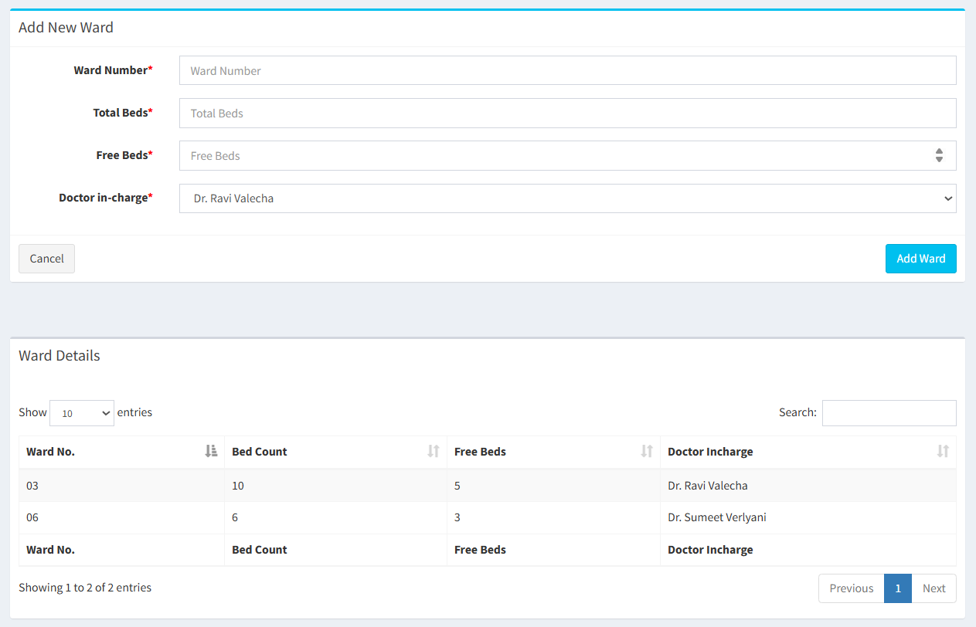

**Figure 7.11.10 Manage Wards**

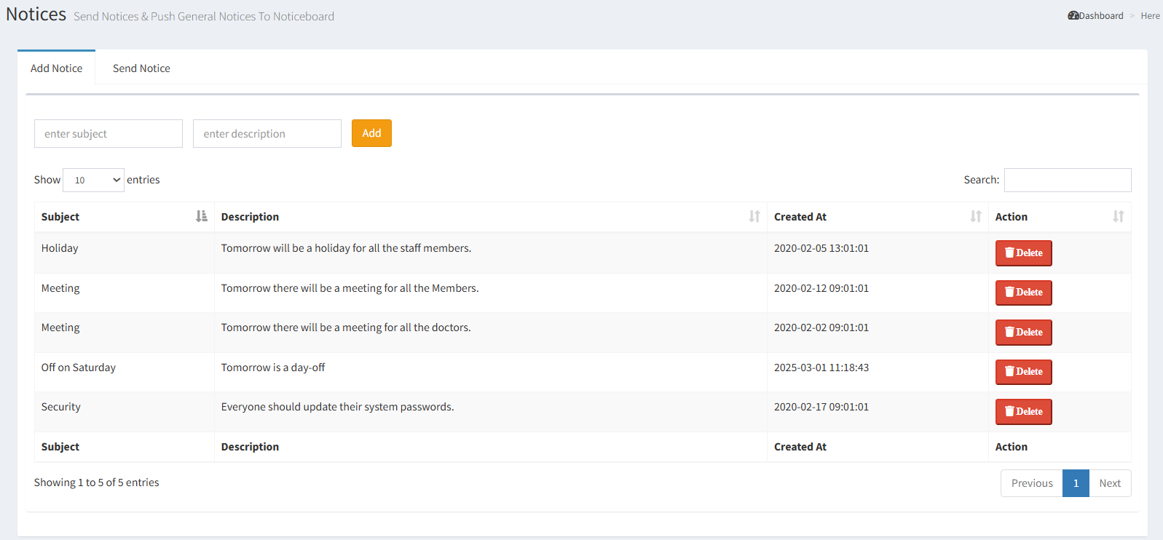

**Figure 7.11.11 Manage Notices**

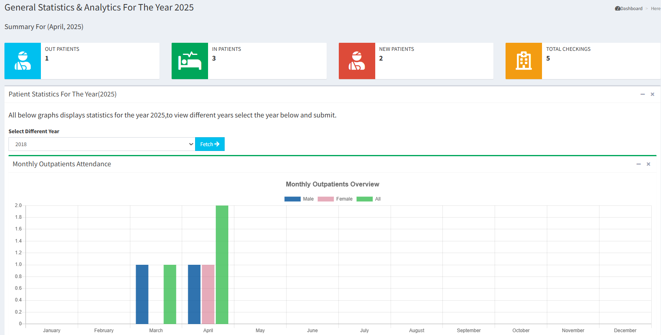

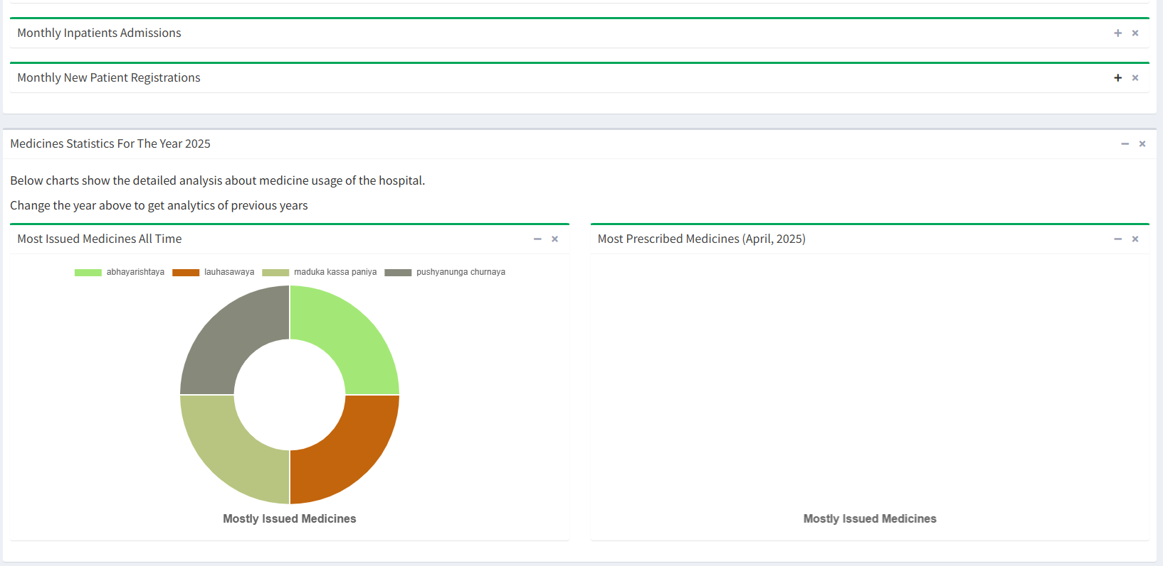

**Figure 7.11.12 General Statistics & Analytics**

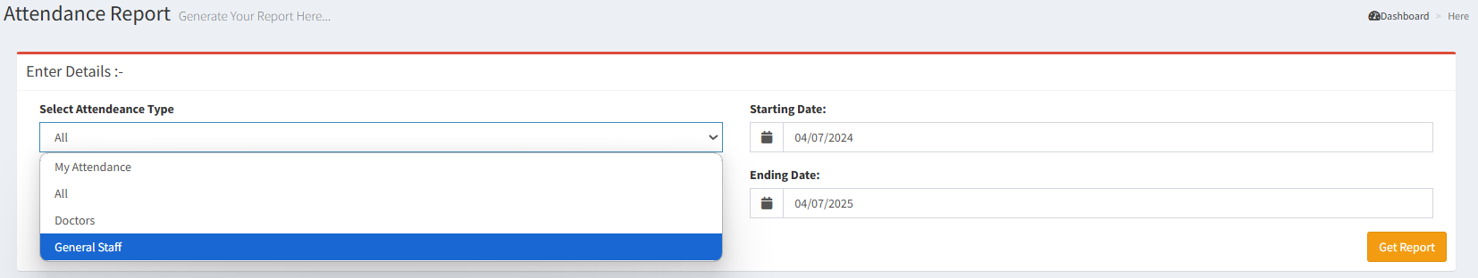

**Figure 7.11.13 Attendance Report**

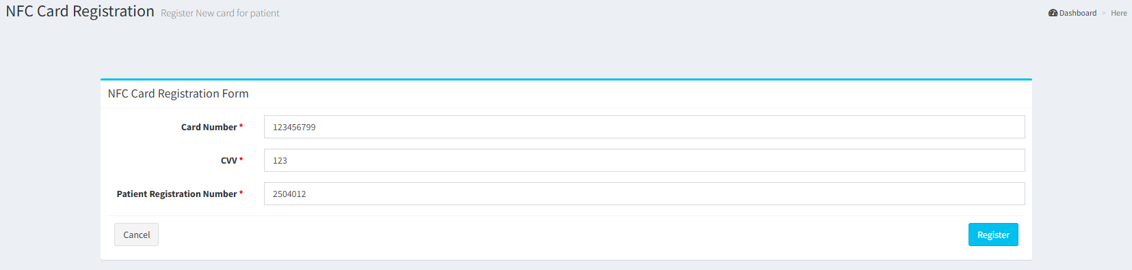

**Figure 7.11.14 Register NFC Card**

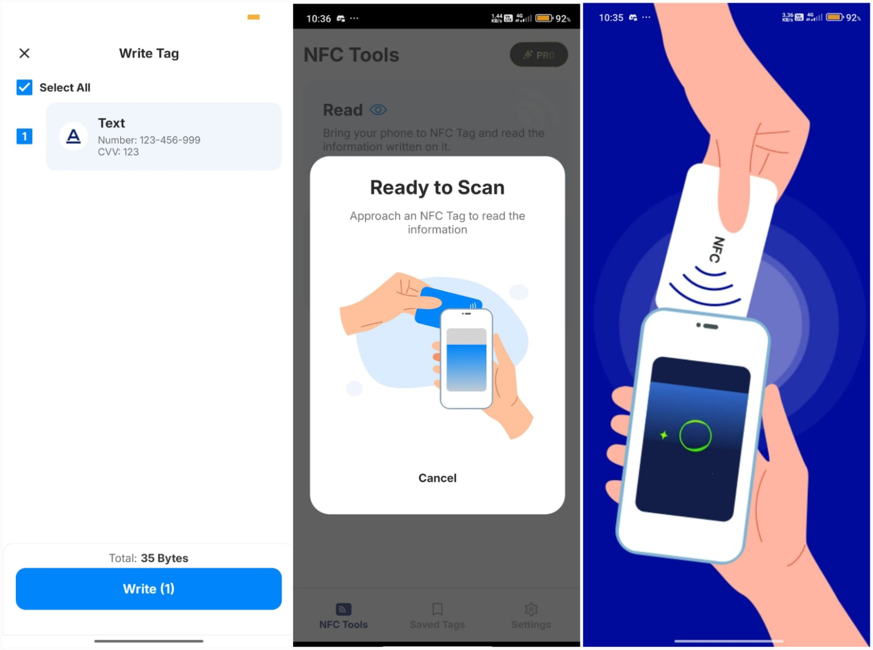

**Figure 7.11.15 Scan NFC Card**

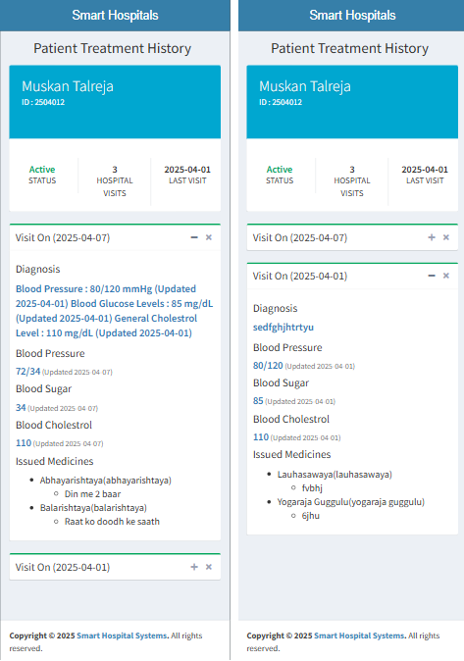

**Figure 7.11.16 View Patient History with NFC**

## 7.2. Performance Evaluation measures

Performance evaluation is essential to determine how efficiently and reliably the system functions under various conditions. The evaluation process focused on measuring the system’s speed, scalability, resource usage, and accuracy in data handling. These metrics help ensure the application meets the real-time requirements of hospital environments and provides a seamless user experience across all modules.

#### **Key Evaluation Metrics:**

1. **Response Time for NFC Card Scan**
   * **Measured Value**: ~1–2 seconds per scan
   * **Purpose**: To ensure that the NFC reader fetches and displays patient data quickly and accurately, especially in critical scenarios such as emergencies.
2. **System Uptime During Testing**
   * **Measured Value**: 99.5% uptime
   * **Purpose**: To evaluate the reliability of the server and Laravel backend for continuous availability across different roles and features.
3. **Load Handling (Concurrent Users)**
   * **Simulated Users**: 20–25 simultaneous users
   * **Result**: No significant performance drop during concurrent logins, data retrievals, or appointment booking operations.
4. **Data Retrieval Accuracy**
   * **Accuracy Rate**: 100% record match via NFC ID
   * **Purpose**: To verify that each NFC card reliably maps to the correct patient profile without misrouting or mismatch.
5. **Page Load Speed (Frontend)**
   * **Average Load Time**: 1.5–2.0 seconds per page/module
   * **Purpose**: Ensures smooth user navigation through the system interface for patients, doctors, and admins.
6. **Security Validation Tests**
   * **Result**: All access control checks passed
   * **Purpose**: To ensure role-based access is strictly enforced and no unauthorized user can access sensitive modules.
7. **Database Query Optimization**
   * **Measured Query Time**: <100 ms for standard patient record fetch
   * **Purpose**: To validate database indexing and the use of optimized queries for fast backend operations.

## 7.3. Input Parameters / Features Considered

To ensure the NFC-based Hospital Patient Management System is functional, secure, and user-friendly, a set of well-defined input parameters and core features were considered during system development and testing. These parameters influenced how each module was designed, validated, and optimized to perform in real-world hospital scenarios.

#### **Key Input Parameters:**

1. **NFC Card Identifier (Unique ID)**
   * A unique alphanumeric ID linked to each patient’s profile in the database.
   * Acts as the key input for scanning and retrieving patient history via the NFC-enabled device.
2. **User Credentials (Email/Password)**
   * Used for login authentication across different user roles (admin, doctor, pharmacist, patient).
   * Ensures secure, role-based access control.
3. **Appointment Details**
   * Includes doctor ID, patient ID, date, time slot, and purpose of visit.
   * Serves as inputs for scheduling, modifying, or cancelling appointments.
4. **Medical History Inputs**
   * Diagnosis details, treatment notes, lab test results, allergies, and past prescriptions.
   * Entered by doctors to build a complete patient profile.
5. **Prescription Information**
   * Inputs like medicine name, dosage, frequency, and duration.
   * Used by both doctors (to issue) and pharmacists (to dispense).
6. **User Role Selection**
   * Determines the access level and available modules for each logged-in user (admin, doctor, patient, pharmacist).
7. **Profile Data**
   * Inputs such as name, age, gender, contact number, address, and emergency contact.
   * Required for initial patient and doctor registration.
8. **System Commands (via UI buttons/forms)**
   * Trigger backend operations like “View Records”, “Book Appointment”, “Generate Prescription”, etc.
   * Connected to Laravel routes and controller functions.

## 7.4. Graphical and Statistical Output

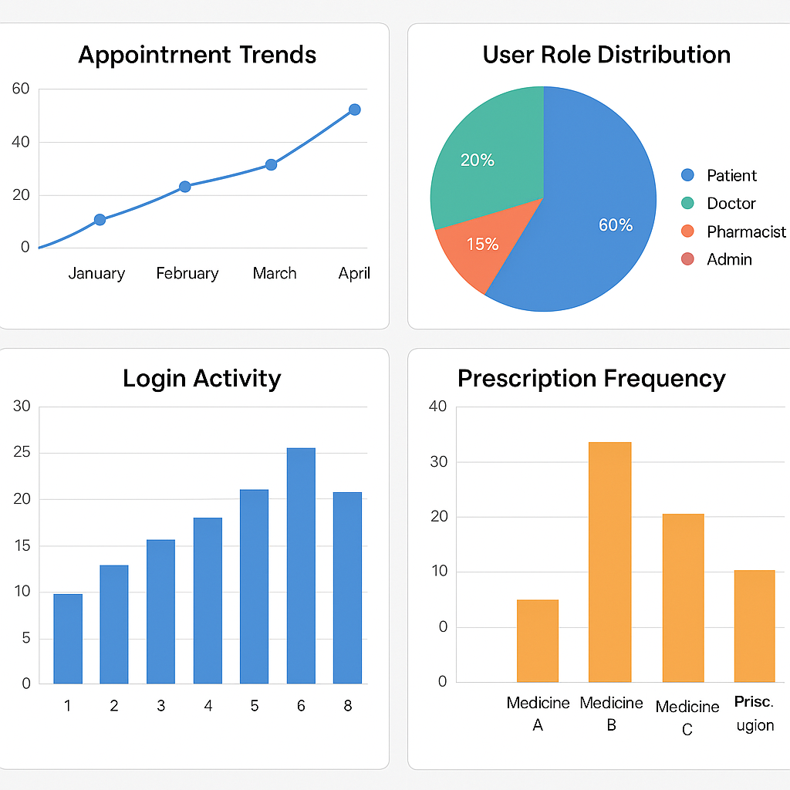

**Figure 7.4.1 Graphical and Statistical Output of the Patient Management System**

The visual representation of the system’s activity through various charts provides meaningful insights into user behavior, module performance, and system usage trends. These charts were generated using test data collected during the development and testing phases.

1. **Appointment Trends (Top Left)** This bar chart displays the number of appointments booked over several weeks. The gradual increase in bookings demonstrates effective adoption of the appointment module and helps administrators identify peak consultation times for better resource allocation.
2. **User Role Distribution (Top Right)** The pie chart represents the distribution of different user roles within the system: patients, doctors, pharmacists, and administrators. The higher proportion of patients is expected, while the balance among other roles ensures smooth healthcare operations.
3. **Login Activity (Bottom Left)** A line chart shows login activity over time, categorized by role. Spikes in doctor and admin logins during weekdays reflect working hours, while patient logins are more spread out, aligning with their appointment timings and prescription checks.
4. **Prescription Frequency (Bottom Right)** This chart shows which medicines were most frequently prescribed within the test dataset. This data assists pharmacists in maintaining inventory and helps doctors review trends for treatment consistency.

These graphical insights not only support system performance evaluation but also lay the groundwork for future enhancements like predictive analytics, demand forecasting, and real-time monitoring dashboards.

## 7.5 Comparison of results with existing systems

| **Criteria** | **Existing Systems** | **Proposed NFC-Based System** |
| --- | --- | --- |
| **Access to Patient History** | Manual search or partial digital access | Instant access via NFC card scan |
| **Interoperability** | Often siloed; limited data exchange | Centralized system with role-based and location-independent access |
| **Technology Used** | Basic web forms, some RFID or barcode systems | Laravel-based web platform with integrated NFC, real-time data access |
| **Appointment Scheduling** | Manual or web-based, sometimes prone to conflicts | Smart scheduling with conflict checks, notifications, and user calendar integration |
| **Prescription Management** | Paper-based or basic digital records | Digitally issued, retrievable via NFC profile and accessible by pharmacists |
| **User Role Management** | Limited or generic user roles | Role-specific dashboards for admin, doctor, patient, and pharmacist |
| **Performance (Data Retrieval)** | Moderate; depends on database structure | Fast; NFC card-based ID fetch reduces load time to ~1-2 seconds |
| **Security Measures** | Password-based, often lacking advanced security | Role-based access, encryption, and secure ID mapping via NFC |
| **Emergency Handling** | Delay in retrieving records | Immediate data access via NFC aids quick decision-making in emergencies |
| **Portability** | Records tied to a single hospital or branch | Patient record accessible at any integrated hospital with NFC reader |
| **Usability for Patients** | Requires paperwork or remembering credentials | Card-based access; no need for remembering usernames or forms |

**Table 7.5.1 Comparison of existing systems**

## 7.6. Inference drawn

From the development, testing, and comparative analysis of the NFC-based Hospital Patient Management System, it can be inferred that the proposed system offers significant improvements in efficiency, accessibility, and user experience over traditional and existing hospital systems. The integration of NFC technology enables rapid access to patient information, which is particularly valuable in emergency situations and helps reduce administrative overhead.

Furthermore, the implementation of role-based modules, real-time scheduling, secure login, and digital prescription management enhances both clinical and administrative workflows. Compared to existing systems that often operate in silos and rely on manual data retrieval, the proposed system provides a centralized and automated solution that is scalable, secure, and user-friendly.

Overall, the system not only meets but exceeds the core functional requirements expected from modern hospital management software, demonstrating that incorporating modern technologies like NFC can substantially transform healthcare operations and improve patient outcomes.

# Chapter 8: Conclusion

## 8.1 Limitations

While the NFC-based Hospital Patient Management System introduces substantial improvements in healthcare data handling and patient interaction, a few limitations were identified during development and testing:

* **Hardware Dependency:** The system requires NFC-enabled smartphones or dedicated readers, which may not be available in all healthcare facilities.
* **Initial Setup Costs:** Implementing NFC infrastructure and training staff involves upfront investment, particularly for hospitals transitioning from fully manual systems.
* **Limited Real-World Testing:** Due to privacy concerns and access restrictions, the system was tested on synthetic data rather than real patient records, which may not reflect certain edge-case scenarios.
* **Network Dependency:** Since the system is web-based, uninterrupted internet connectivity is essential for accessing records and performing operations in real-time.
* **Limited Telemedicine Features:** While foundational modules are in place, full-scale virtual consultation features remain under development.

## 8.2 Conclusion

The proposed NFC-based Hospital Patient Management System demonstrates a practical, efficient, and scalable solution to modern-day healthcare challenges. By integrating NFC technology, the system enhances the speed, accuracy, and security of accessing patient records. The modular design supports role-based operations—tailored to administrators, doctors, pharmacists, and patients—ensuring that each user interacts with the system according to their responsibilities.

The use of Laravel and MySQL technologies allowed for secure backend processing and structured data storage. Overall, the system not only reduces administrative burdens but also improves healthcare delivery by facilitating quicker decisions, especially in emergencies. The project successfully meets the objectives of building a centralized, paperless, and user-friendly hospital management system.

## 8.3 Future Scope

The system offers a strong foundation and several opportunities for future enhancements:

* **Mobile Application Development:** A dedicated Android/iOS app for patients and doctors can make healthcare services more accessible on the go.
* **Advanced Analytics Integration:** Introducing machine learning to predict health trends, suggest diagnoses, and analyze treatment effectiveness.
* **Telemedicine Expansion:** Adding features for secure video consultations, e-prescription sharing, and remote diagnostics.
* **Blockchain for Health Records:** Implementing blockchain to enhance data integrity, auditability, and interoperability between institutions.
* **Multi-Language Support:** Expanding the system with regional language options to improve usability for patients in diverse communities.
* **Integration with National Health Portals:** Synchronizing the platform with government or insurance databases for seamless claim processing and compliance.

# References

**[1] B. Koyuncu and H. Koyuncu, "Intelligent Hospital Management System (IHMS)," *2015 International Conference on Computational Intelligence and Communication Networks (CICN)*, Jabalpur, India, 2015, pp. 1602-1604, doi: 10.1109/CICN.2015.305.**

**[2] S. Mukherjee, K. Dolui and S. K. Datta, "Patient health management system using e-health monitoring architecture," *2014 IEEE International Advance Computing Conference (IACC)*, Gurgaon, India, 2014, pp. 400-405, doi: 10.1109/IAdCC.2014.6779357.**

**[3] D. S. R. Krishnan, S. C. Gupta and T. Choudhury, "An IoT based Patient Health Monitoring System," 2018 International Conference on Advances in Computing and Communication Engineering (ICACCE), Paris, France, 2018, pp. 01-07, doi: 10.1109/ICACCE.2018.8441708.**

**[4] B. Chowdhury and R. Khosla, "RFID-based Hospital Real-time Patient Management System," *6th IEEE/ACIS International Conference on Computer and Information Science (ICIS 2007)*, Melbourne, VIC, Australia, 2007, pp. 363-368, doi: 10.1109/ICIS.2007.159.**

**[5] I. Chiuchisan, H. -N. Costin and O. Geman, "Adopting the Internet of Things technologies in health care systems," *2014 International Conference and Exposition on Electrical and Power Engineering (EPE)*, Iasi, Romania, 2014, pp. 532-535, doi: 10.1109/ICEPE.2014.6969965.**

**[6] Polu, Sandeep Kumar. (2018). NFC based Smart Healthcare Services System. JIRST –International Journal for Innovative Research in Science & Technology| Volume 5 | Issue 7 | December 2018 ISSN (online): 2349-6010**

**[7] O. Ebere *et al*., "NFC tag-based mHealth Patient Healthcare Tracking System," *2022 3rd International Conference on Next Generation Computing Applications (NextComp)*, Flic-en-Flac, Mauritius, 2022, pp. 1-6, doi: 10.1109/NextComp55567.2022.9932185.**

**[8] G. V. Ukalkar and P. S. Halgaonkar, "Cloud based NFC health card system," *2017 International Conference on Intelligent Computing and Control Systems (ICICCS)*, Madurai, India, 2017, pp. 436-441, doi: 10.1109/ICCONS.2017.8250760.**

**[9] G. M. Bianco *et al*., "Towards a Hybrid UHF RFID and NFC Platform for the Security of Medical Data from a Point of Care," *2022 IEEE 12th International Conference on RFID Technology and Applications (RFID-TA)*, Cagliari, Italy, 2022, pp. 142-145, doi: 10.1109/RFID-TA54958.2022.9923987.**

# Appendix

# 1. Paper I & II Details

## Paper published

Submitted

b. Plagiarism Report

## Plagiarism report

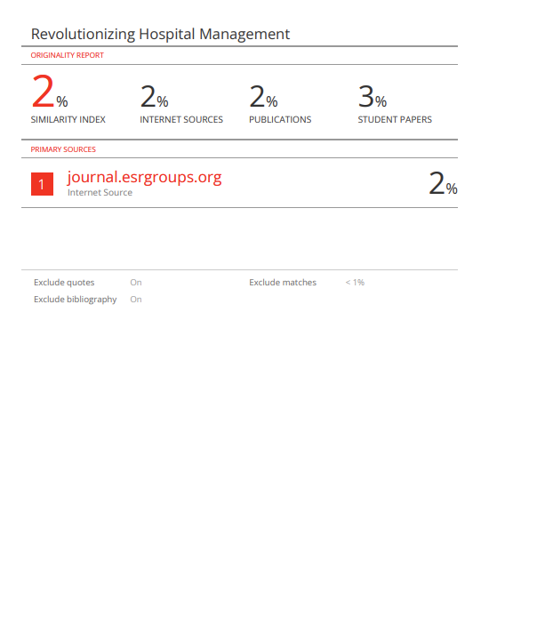

## Project review sheet

**i. Review 1**

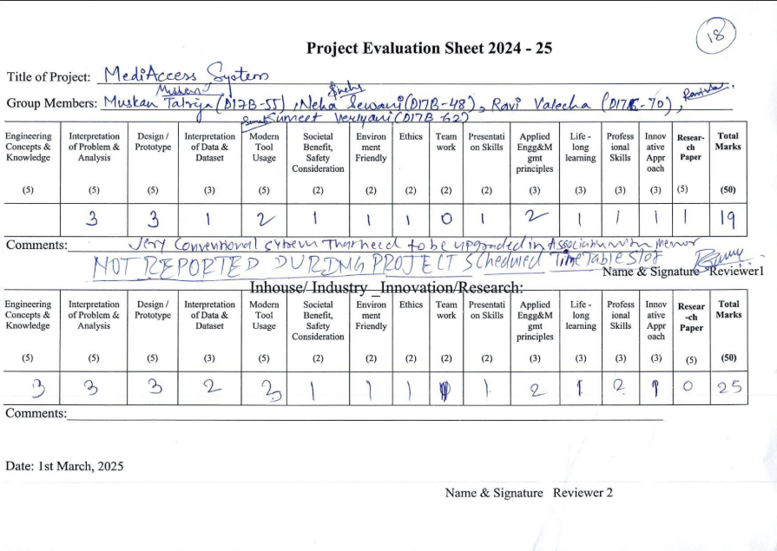

**ii. Review 2**

